Technical Report
IoT-Raspberry Project: Visitor Count

Lassi Koivusalo, Kaapo Koponen, Teemu Kruteleff, Joonas Lappalainen

Table of Contents

1 GIT-Repository 3
2 Assembly 3
2.1 Raspberry Pi 4
2.2 Other hardware 4
2.3 HC-SR04 Ultrasound Sensor 5
2.3.1 Wiring Diagram 6
3 Database 7
3.1 Ubuntu Server 7
3.1.1 MySQL Server 7
3.1.2 SSH 7
4 Desktop 8
4.1 PHPGraphLib 8
4.2 Apache 9
4.3 PHP 10
4.4 MYSQL-server 10
4.5 SSH 10
5 Code 11
5.1 11

- GIT-Repository
All the various codes and documentation for the project can be found at a public GIT-repository under the following address.
https://github.com/GarStiver/Sensor-Project
Everything is licensed under GNU General Public License v. 2.0 and other specific licences can be found at an appropriate section below.

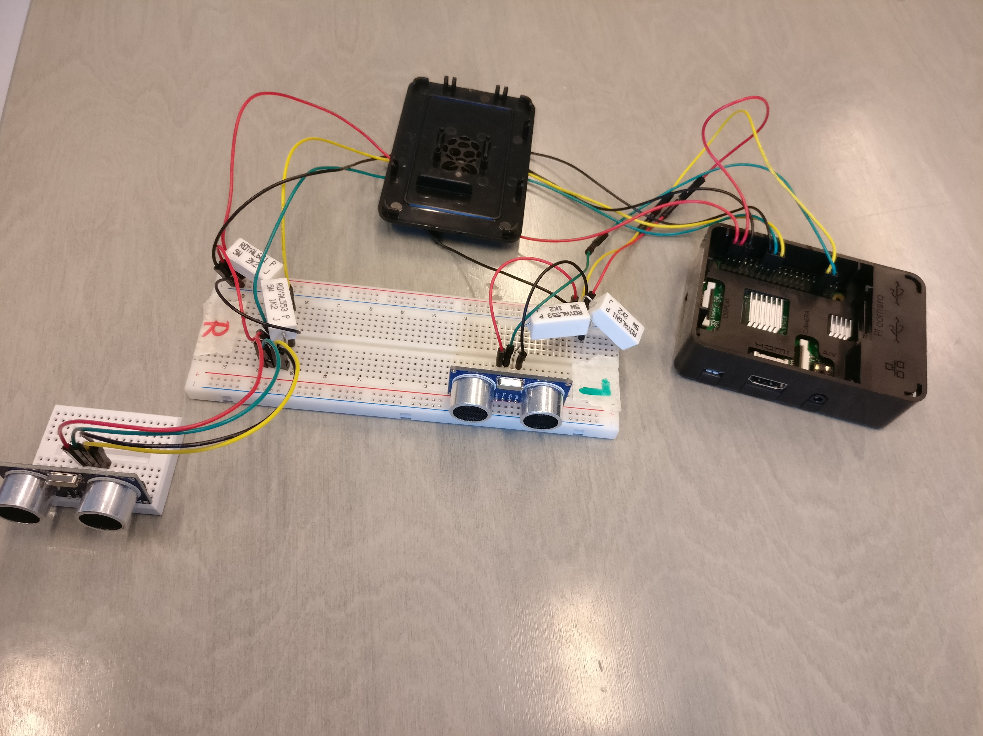
- Assembly
Picture 1 Raspberry Pi setup

Raspberry Pi

The chosen OS for the Raspberry Pi was Raspbian JESSIE Lite, which can be downloaded from the following address.
https://www.raspberrypi.org/downloads/raspbian/
The following programs were installed on Raspberry Pi.
- PYTHON
- GIT
- PIP

Other hardware

The following hardware are required for this project and were used in this particular setting. In some cases, other kind of assemblies can be used to achieve the same results.
- HC-SR04 Ultrasound sensor (x2)
- Breadboard MINI
- Breadboard STANDARD
- Jumper wires (x21)
- Resistor 5W: 1,2kOhm (x2) & 2,2kOhm (x2)

HC-SR04 Ultrasound Sensor
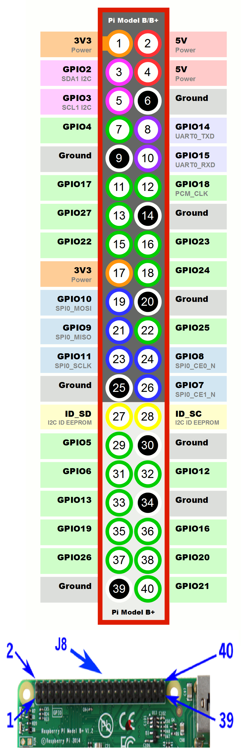
We used two ultrasound sensors to measure activity that goes by a desired area, preferably a doorway.
Following the image on the left, the sensors were attached to Raspberry Pi’s GPIO as follows.
- Left Sensor
  - 4th pin 5V
    - Power
  - 14th pin Ground
  - 33rd pin GPIO13
    - Echo
  - 35th pin GPIO19
    - Trig
- Right Sensor
  - 2nd pin 5V
    - Power
  - 6th pin Ground
  - 18th pin GPIO24
    - Echo
  - 16th pin GPIO23
    - Trig

Wiring Diagram

The following schematics are for the HC-SR04 sensors.
In this project, they were connected to separate breadboards via jumper wires, which were then connected to the Raspberry Pi. Nothing prevents connecting these directly to it however.

Database
The database structure is simple. It has one database which includes one table. The table has three columns: id, state and time.

id | state | time
Identification number | Current visitor count | Timestamp

Ubuntu Server

For this project, an Ubuntu virtual computer was hosted on the CloudPlatform, on which the database was set up.

MySQL Server

MySQL server was installed to the database virtual computer via the package “mysql-server”. It was used to make the database where all the data from the raspberry and sensors was stored

SSH

SSH was installed on the Ubuntu server via “openssh-server” command. It was needed to gain quick access to the virtual database computer with the use of PuTTy and ssh connections from different computers.

Desktop
Xubuntudesktop was used to create and test the php/html pages we made to demonstrate and describe the information we were able to generate using our raspberry pi and the 2 sensors. The information to log into our Computer called Xubuntudesktop were: username: krogan and password: xubuntucolamusta. It was made on the CloudPlatform using the template: xubuntu-16.04.1-desktop-amd64. You can see the version number of the Ubuntu on the name same as the information that it was 64bit version.

PHPGraphLib

We used PHPGraphLib for creating the graphs to showcase the data our raspberry and sensors were generating. PHPGraphLib is an open source lightweight PHP-based graphing library that creates PHP graphs that are easy to implement into webpages as the files made by it are .png files that are easy to add to normal html pages as images. all the necessary information for using PHPGraphLib can be found on the developer’s home site http://www.ebrueggeman.com/phpgraphlib
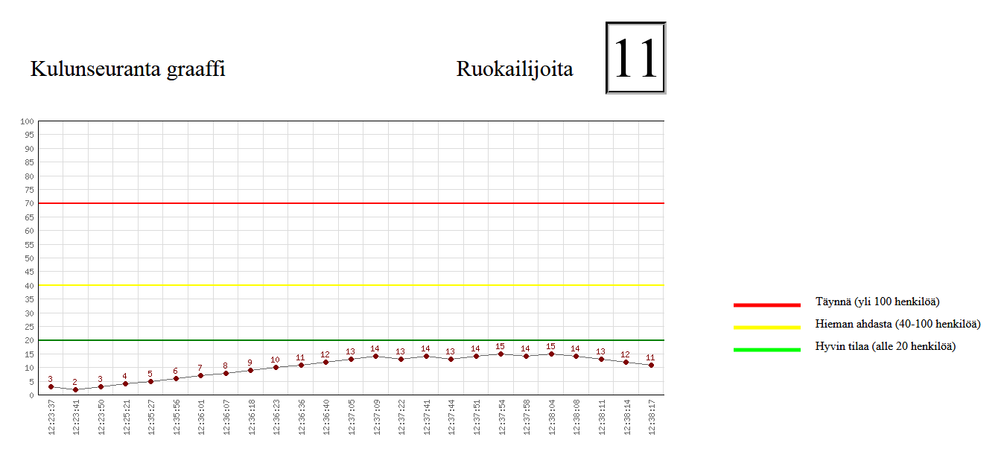

Apache

We had LAMP installed into our desktop computer and that meant we also installed apache. It’s the most used HTTP web server and it is also open source. We installed it to our computer to be able to use mysql database from the database virtual computer and also to be able to use php for the webpage that had our graph made by PHPGraphLib. To install apache we installed package “apache2” and activated “a2enmod userdir” – module with the command “sudo a2enmod userdir”

PHP
We had to install PHP to be able to create the website where our data from pi and sensors was made into a graph where it was easy to understand. We installed the php.7.0 version to the desktop and also a package “php libapache2-mod-php”.

MYSQL-server
Basically mysql server was not needed for the desktop here, but we installed LAMP at the beginning of the project just to be sure so as part of that we also had Mysql-server on the desktop computer even thou all the actual databases were on the Database virtual computer.

SSH

We installed SSH-package “openssh-server” to the desktop as it was needed to edit the php files fast using PuTTy.

Code
This part of the report is for the Python code. Here we are about to go through the entire Python code that was used in the project.

Let us start with the Variables.py as it is the smallest of the python files. Here we establish most of the variables used in the project. The visitorCount -variable is for counting the people that have passed the sensors.
MaxDistance, which is set to 100cm, determines when a person is added or removed from the counter.
DistanceLeftC is the distance counted by the left sensor. DistaceRightC does the same thing for the right sensor.

# Variables used in the sensor project
visitorCount = 0
maxDistance = 100
distanceLeftC = 0
distanceRightC = 0

The code below is called the DBConnector.py in this project. As you can imagine this code connects our project to our database called sensor_data which was created with mysql. The first lines import the libraries and other Python files used by this file. To get the connector to work we had to install a python installer called pip. With pip we downloaded and installed the pymysql and pymysql.cursors libraries. The time library is not used in the final product.

import pymysql
import pymysql.cursors
import Variables
import time

Here we actually connect to the database. To connect we are required to enter the ip of the machine running the database (in this project a virtual machine), the port number which in this case is 3306. The username, the password and database name are also required.
# Connect to the database
connection = pymysql.connect(host='10.207.3.0',
port=3306,
user='quaria',
password='debiancolasininen',
db='sensor_data',
charset='utf8mb4',
cursorclass=pymysql.cursors.DictCursor)

The function below is for getting the last value of state which is then assigned to the visitorCount-variable.

# Gets the last value of the state row and inserts it into the visitorCount variable
def getLastValue():
with connection.cursor() as select:
# Get all rows
sqlS = "SELECT id, state, time FROM raw_data"
select.execute(sqlS)
for row in select:
Variables.visitorCount = "%s" % (row["state"])
connection.commit()

The next two functions are for inserting new values into the database when a person has entered or left the cafeteria. While writing this report I came to conclusion we could have done with just insert statement instead of two.
def insertIncrease():
with connection.cursor() as cursor:
# Plus to visitorcount in database
sql = "INSERT INTO raw_data (state) VALUES (%s)"
cursor.execute(sql, Variables.visitorCount)
connection.commit()

def insertDelete():
with connection.cursor() as cursor2:
# Minus from visitorcount in database
sql2 = "INSERT INTO raw_data (state) VALUES (%s)"
cursor2.execute(sql2, Variables.visitorCount)
connection.commit()

Next we are going to go through both of the actual distance counters called distance and distanceRight. I am only going to go through one of them because they are actually the same file just with differently named variables and different trigger and echo bin placements.
Here we import the RPi.GPIO library installed using pip. Raspberry pi already had this installed but as we programmed the entire code using Pycharm we also had to install this separately. RPi.GPIO library is required for every IOT-project created using Raspberry Pi that uses sensors of any type. The time library is required for measuring the actual distance. This Python file also uses the Variables.py that was described before.
import RPi.GPIO as GPIO
import time
import Variables

Here we determine which type the code uses the Raspberry pi’s pins.
GPIO.setmode(GPIO.BCM

Here we assign the trigger and the echo pins to the Pi’s pins. And we also assign the Variables.distanceRightC to dleft variable.

# Defining Trigger and Echo pin locations on Rasp
pinTriggerLeft = 19
pinEchoLeft = 13
dleft = Variables.distanceRightC

Next we setup our two GPIO ports as either inputs or outputs.

# Setting up the trigger and echo pin Outputs and Inputs
GPIO.setup(pinTriggerLeft, GPIO.OUT)
GPIO.setup(pinEchoLeft, GPIO.IN)

Here we have created a function called SensorRangeLeft. Here the GPIO.output sends a small shock to turn on the trigger pin and then turns it off. After this the time.time variable is assigned to two variables: startTimeLeft and stopTimeLeft.

# Counts the distance of the left sensor and return the value of dleft
def SensorRangeLeft(dleft):
GPIO.output(pinTriggerLeft, True)
time.sleep(0.00001)
GPIO.output(pinTriggerLeft, False)
startTimeLeft = time.time()
stopTimeLeft = time.time()

Here we save the start time in the first while and save the time of arrival in the second while loop.
while 0 == GPIO.input(pinEchoLeft):
startTimeLeft = time.time()

while 1 == GPIO.input(pinEchoLeft):
stopTimeLeft = time.time()

Here we count the difference between the stopTimeLeft and the startTimeLeft. After this multiply the value of TimeElapsedLeft by 34300 and after that divide it by 2. Finally we assign the value to the dleft variable.
TimeElapsedLeft = stopTimeLeft - startTimeLeft

dleft = (TimeElapsedLeft * 34300) / 2

Finally if the value of dleft is below 2500 it prints the value.
if dleft < 2500:
print ("DistanceLeft: %.1f cm" % dleft)
time.sleep(0.5)

return dleft

Finally is the distanceBoth.py-file. This is the file where we run the entire program. Here we start by importing most of the other python files and also sys and signal for terminating the software.
from distanceRight import *
from distance import *
import Variables
import DBConnector
import sys
import signal

Here we have a function called checkLeft that is called from the while loop below if a certain requirement is met. If the actual requirement is met the program checks if the distance measured by the right sensor is below the maxDistance. If that happens to be true the program further checks that if the visitorCount is equal or below to zero. If this is also true the program prints the value of visitorCount and calls the insertDelete-function.
# If the left sensor's range is below maxdistance the program checks
# if the right sensor's range is also below 50cm.
# If that is true the program lowers the visitorcount by one.
def checkLeft():
if SensorRangeRight(dright) < Variables.maxDistance:
if int(Variables.visitorCount) >= 0:
Variables.visitorCount = int(Variables.visitorCount) - 1
print (Variables.visitorCount)
DBConnector.insertDelete()

Here we have a similar function to the previous one but this one checks if the left sensor is below maxdistance. If it is the value of visitorcount is increased by one. This function is also called from the while loop.

# If the right sensor's range is below maxdistance the pro gram checks
# if the left sensor's range is also below 50cm.
# If that is true the program increases the visitorcount by one.
def checkRight():
if SensorRangeLeft(dleft) < Variables.maxDistance:
Variables.visitorCount = int(Variables.visitorCount) + 1
print(Variables.visitorCount)
DBConnector.insertIncrease()

This method cleans up the Raspberry Pi connection when the program is should down.

# Closes and cleans up the run
def close(signal, frame):
print("\nTurning off ultrasonic distance detection...\n")
GPIO.cleanup()
sys.exit(0)

signal.signal(signal.SIGINT, close)

Here we have a small function call that calls the getLast Value from the DBConnector to get the last value of state for the software.

# Calls the getLastValue method in the DBConnector.py file to check
# the previous visitorcount.
DBConnector.getLastValue()

Finally we have a while loop that runs both of the sensors to check if their values are below maxdistance. If that is true they call their respective functions.

# Checks the value of both sensors and calls the corresponding method
# if the value is below maxDistance
while True:

if SensorRangeLeft(dleft) < Variables.maxDistance:
checkLeft()

if SensorRangeRight(dright) < Variables.maxDistance:
checkRight()

https://github.com/PyMySQL/PyMySQL

